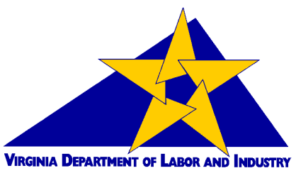
VIRGINIA DEPARTMENT OF LABOR AND INDUSTRY
VIRGINIA OCCUPATIONAL SAFETY AND HEALTH (VOSH) PROGRAM
MEDIA PACKET
Virginia State Plan for Occupational Safety and Health
The Commonwealth of Virginia’s Department of Labor and Industry administers the Virginia State Plan for Occupational Safety and Health (VOSH) under grants from the Occupational Safety and Health Administration (OSHA), U. S. Department of Labor (USDOL). State Plans are authorized under §18 of the Occupational Safety and Health Act of 1970 (OSH Act), 29 USC 651, et seq.
Grants to states are authorized under §23(g) for compliance programs in the private and public sectors as well as onsite consultation for public sector with funding of 50% from the federal government and 50% from the Commonwealth. Section 21(d) of the OSH Act provides grants for free private sector consultation to small employers with funding of 90% from the federal government and 10% from the Commonwealth.
Section 18(e) of the OSH Act provides that a State Plan may seek “final approval” of the program so that the state can assume exclusive jurisdiction over most aspects of OSH Act jurisdiction. The VOSH program has received final approval of its program from OSHA.
Important Dates
Initial State Plan Approval: September 28, 1976
Program Certification Date: August 15, 1984
Final Approval Date: November 30, 1988
VOSH Budget
Federal Fiscal Year (September-October): FFY 2021 23(g) $8,664,800 (50% federal - 50% state funds)
Federal Fiscal Year (September-October): FFY 2017 21(d) $1,621,333 (90% federal - 10% state funds)
100% State Plan Funds as of June 30, 2021: $350,000
TOTAL FFY 2021: $10,636,133
VOSH Coverage
The role of the VOSH Program is to enforce safety and health regulations for general industry, construction, agricultural, and state and local government maritime employers in Virginia. The VOSH Program covers both state and local government and private sector employers and workers in Virginia. VOSH does not cover certain federal enclaves (e.g., military reservations) and the U. S. Postal Service.
In addition, certain industries are exempted from OSHA coverage nationwide by §4(b)(1) of the OSH Act where another federal agency exercises statutory authority to prescribe or enforce standards or regulations affecting occupational safety and health (e.g., the Nuclear Regulatory Commission, Federal Railroad Administration, United States Coast Guard, Federal Aviation Administration, Mine Safety and Health Administration, etc.).
VOSH conducts safety and health inspections in response to accidents, complaints, referrals, and randomly scheduled inspections of high hazard industries. In addition to enforcement efforts, VOSH provides compliance assistance through targeted outreach, education, and training to emphasize increased awareness on the part of both employers and workers of the importance of a safety and health culture.
The VOSH Program mirrors the federal program in many areas but has adopted some different statutes, regulations, policies and procedures to address unique characteristics of the Commonwealth.
Profile of the Virginia State Plan
Profile of the Virginia State Plan (FY 2021)
Designee | Gary Pan, Commissioner  Virginia Department of Labor and Industry  Main Street Centre  600 East Main Street, Suite 207  Richmond, Virginia 23219-4101
Initial Approval | September 28, 1976
Plan Certification | August 15, 1984
Final Approval | November 30, 1988
FY 2021 23(g) Funding | Federal | $4,332,400
 | State | $4,332,400
 | TOTAL | $8,664,800
Source of State Funding | General fund and non-general fund  100% State Plan Funds as of June 30, 2021: $350,000
Compliance Officers | Allocated Positions |  | 38 safety/19.88 health
 | On-Board as of May 1, 2022 |  | 31 Safety / 17 Health
State and Local  Government Consultants | Allocated Positions |  | .20 safety/1.60 health
 | On-Board as of May 1, 2022 |  | .20 safety/.30 health
Compliance Assistance | Allocated Positions |  | 7.0 CAS
 | On-Board as of May 1, 2022 |  | 1.0 CAS
Covered Workers | 3.73 million
Covered Establishments | 280,681
Coverage | State and local government and private sector workplaces within the state, with the exception of federal workers, the United States Postal Service, private sector maritime, federal military facilities, and other federal enclaves where the state has ceded coverage to the federal government.

VOSH Laws and Regulations
The VOSH Program administers occupational safety and health activities in the Commonwealth through the Virginia State Plan agreement with federal OSHA as required by Va. Code §40.1-1. The VOSH program is required by the OSH Act to be “at least as effective as” federal OSHA (29 USC 667(c)) and is monitored by OSHA on an annual basis. Financial audits occur every two to three years. In accordance with §40.1-22, the Virginia Safety and Health Codes Board is charged with adopting occupational safety and health standards and regulations applicable to Virginia employers.
The majority of VOSH laws and regulations are identical to OSHA. However, VOSH has enacted unique laws and regulations covering overhead high voltage line safety; tree trimming operations; fall protection in steel erection; reverse signal operation in construction and general industry; compliance with manufacturer’s instruction for vehicles, machinery, tools and equipment in general industry, construction, maritime and agriculture; and confined spaces in the telecommunication industry.
VOSH also has an abatement verification regulation that requires not only abatement certification (i.e., the employer’s signed statement that abatement has occurred), but also requires employers to provide photographs, receipts, purchase orders, etc., as verification that a hazard was abated.
Demographic Profile
Under Virginia’s State Plan, VOSH has jurisdiction over approximately 3.73 million workers in over 280,000 establishments in covered industries:
Industry | Industry Code |  | Establishments | Employment
Total, All Industries |  | 0 | 280681 | 3735061
Agriculture, Forestry, Fishing and Hunting |  | 11 | 1769 | 13239
Mining, Quarrying, and Oil and Gas Extraction |  | 21 | 288 | 4904
Other Services (except Public Administration) |  | 81 | 29449 | 123778
Accommodation and Food Services |  | 72 | 17649 | 279468
Utilities |  | 22 | 578 | 18249
Real Estate and Rental and Leasing |  | 53 | 10687 | 53321
Arts, Entertainment, and Recreation |  | 71 | 3610 | 59013
Retail Trade |  | 44-45 | 25493 | 391874
Wholesale Trade |  | 42 | 10923 | 104061
Construction |  | 23 | 21477 | 211669
Information |  | 51 | 5027 | 69336
Transportation and Warehousing |  | 48-49 | 6476 | 153523
Administrative and Support and Waste Management |  | 56 | 14398 | 236590
Health Care and Social Assistance |  | 62 | 46026 | 485651
Finance and Insurance |  | 52 | 12148 | 141726
Manufacturing |  | 31-33 | 7019 | 243384
Educational Services |  | 61 | 4166 | 336591
Management of Companies and Enterprises |  | 55 | 2357 | 79287
Professional, Scientific, and Technical Services |  | 54 | 43427 | 443618
Public Administration |  | 92 | 4290 | 261538
Unclassified establishments |  | 99 | 13424 | 24241
Source: Virginia Quarterly Census of Employment and Wages (QCEW), Third Quarter 2020

Agency Programs
Compliance
VOSH consists of two major units: compliance and cooperative programs. The compliance unit inspects places of work; issues citations, penalties, and abatement dates for violations of established occupational standards; and responds to fatalities, accidents, and worker complaints about workplace safety and health hazards.
Scheduling of inspections is accomplished through an administrative plan, which prioritizes our inspections as follows:
• imminent danger situations;
• fatality/accident inspections;
• employee complaints or referrals from a knowledgeable source; and
• programmed/planned inspections.

Programmed/planned inspections consist of General Schedule and Special Emphasis inspections. General Schedule inspections are initiated from a list of high hazard industries in a random manner and are conducted only when there are no higher priority inspections available. The VOSH Program has a General Schedule for the Manufacturing Industry and Construction.
Special Emphasis inspection programs are developed either by the VOSH program or federal OSHA and are designed to address employers in industries with high rates of injuries or illnesses or a specific safety or health hazard with identified high hazard working conditions.
Violations and Penalties
Type of Violation | Minimum Penalty | Maximum Penalty
Serious | $600 | $13,434
Willful | $10,000 | $134,333
Repeat | N/A | $134,333
Failure-to-abate | N/A | $13,434 per day
Other-than-serious | N/A | $13,434

In assessing penalties, VOSH is required to consider “the size of the business of the employer being charged, the gravity of the violation, the good faith of the employer, and the history of previous violations”, Va. Code §40.1-49.4.A.4.(a).
VOSH also has a maximum fine of $70,000 and/or imprisonment for not more than six months for any willful violation found to cause the death of an employee for the first such conviction – the punishments double for a second conviction (§40.1-49.4.K). Individuals whose flagrant, culpable and wanton violation of VOSH laws and regulations results in the death of an employee may also be subject to a charge of manslaughter.
Employers may contest citations, penalties and orders of abatement issued as the result of a VOSH inspection or investigation. Employers are not required to abate violations that have been contested until the contest is resolved through settlement or litigation. Employees may contest the order of abatement. The notice of contest must be mailed or delivered by hand within fifteen days from the receipt of the citation, proposed penalty or order of abatement. Upon receipt of a notice of contest, the Commissioner will attempt to resolve the matter by settlement, either by participation in an informal conference or through a formal settlement process.
If the matter is not settled or it is determined a settlement is not probable, the Commissioner will initiate judicial proceedings by referring the contested issues to the appropriate Commonwealth attorney. Virginia does not use an administrative law judge and review commission system to handle litigated cases. Virginia is unique among State Plans in using local circuit courts and prosecutors (Commonwealth Attorneys) to litigate contested cases. Attorneys assigned to VOSH’s Division of Legal Support have been approved by the Office of the Attorney General to represent VOSH in litigation when they are appointed by the local Commonwealth’s attorney and the Circuit Court judge on a case-by-case basis. Circuit court decisions at trial are appealable to the Virginia Court of Appeals.
Whistleblower/Anti-discrimination protections are afforded to employees who engage in activities protected by Virginia occupational safety and health laws and regulations (e.g., filing an employee complaint regarding safety or health hazards in the workplace, participating in a VOSH inspection, etc.). Va. Code §§40.1-51.2:1 and -51.2:2. The VOSH Office of Whistleblower Protection (OWP) conducts investigations of employee complaints of discrimination.
Inspection Statistics
NOTE: The COVID-19 pandemic significantly impacted VOSH Compliance and Cooperative Programs' activities during calendar year 2020.
CATEGORIES OF OCCUPATIONAL SAFETY AND HEALTH INSPECTIONS
Calendar Year | 2018 |  | 2019 |  |  | 2020
 | Safety | Health |  | Safety | Health |  | Safety | Health
Planned | 1,058 | 153 | Planned | 1,069 | 235 | Planned | 783 | 178
Follow-Up | 19 | 1 | Follow-Up | 15 | 2 | Follow-Up | 13 | 0
Complaint | 197 | 230 | Complaint | 227 | 173 | Complaint | 139 | 135
Referral | 169 | 48 | Referral | 173 | 74 | Referral | 168 | 72
Accident/Fatality/Cat. | 34 | 3 | Accident | 17 | 3 | Accident | 29 | 1
 |  |  | Fatality/Cat. | 36 | 4 | Fatality/Cat. | 30 | 22
Other | 99 | 55 | Other | 115 | 60 | Other | 73 | 25
Totals | 1,612 | 494 | Totals | 1,652 | 551 | Totals | 1,235 | 433

CATEGORIES OF VIOLATIONS ISSUED
Calendar Year | 2018 |  | 2019 |  | 2020
 | Safety | Health | Safety | Health | Safety | Health
Serious | 1,684 | 420 | 1,529 | 482 | 1,114 | 283
Willful | 3 | 3 | 16 | 3 | 7 | 0
Repeat | 77 | 5 | 69 | 4 | 65 | 0
Other (OTS&FTA) | 624 | 321 | 549 | 335 | 364 | 228
Totals | 2,388 | 749 | 2,163 | 824 | 1,550 | 511

CATEGORIES OF PENALTIES ASSESSED (IN DOLLARS)
Calendar Year | 2018 |  | 2019 |  | 2020
 | Safety | Health | Safety | Health | Safety | Health
Totals | $4,710,703 | $1,691,972 | $6,497,562 | $1,691,038 | $683,397 | $4,686,798

CATEGORIES OF VIOLATION INSTANCES AND EXPOSED EMPLOYEES
Calendar Year | 2018 | 2019 | 2020
Violation Instances | 15,718 | 12,870 | 11,425
Exposed Employees | 60,902 | 32,195 | 27,837

Cooperative Programs
VOSH cooperative programs provide assistance to Virginia’s state and local government and private sector employers to voluntarily comply with applicable requirements without the issuance of citations and penalties.
The VOSH consultation program provides free on-site surveys and technical assistance to Virginia small businesses in high-hazard industries, and to state and local government employers under the State Plan 21(d) grant. https://www.doli.virginia.gov/vosh-programs/consultation/

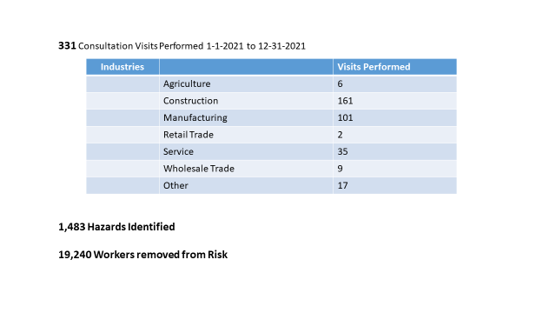
VOSH has two safety and health management system programs designed primarily for small businesses and larger employers respectively.

SHARP
The Safety and Health Achievement Recognition Program (SHARP) recognizes small, high-hazard businesses of 250 or fewer employees that have developed and implemented exemplary safety and health management systems. Virginia SHARP sites regularly maintain injury and illness rates 60% or more below the national average for their respective industries. As of May 1, 2022, there were 16 active SHARP sites with another 12 pursuing SHARP status. Visit the SHARP site for more information on the SHARP program at https://www.doli.virginia.gov/vosh-programs/safety-and-health-achievement-recognition-program/.
VPP
The Virginia Voluntary Protection Program (VPP) recognizes and promotes exceptional safety and health management systems. In VPP management and labor establish a cooperative relationship at a general industry, construction or public sector workplace to develop and implement an exceptional safety and health program. Visit the VPP site for more information: https://www.doli.virginia.gov/voluntary-protection-program/.
Virginia STAR
Virginia STAR sites, the highest level of recognition, regularly maintain injury and illness rates 60% or more below the national average for their respective industries.
As of May 1, 2022, there were 37 active Virginia STAR sites. Visit the VPP site for more information on the VPP Program at https://www.doli.virginia.gov/voluntary-protection-program/.
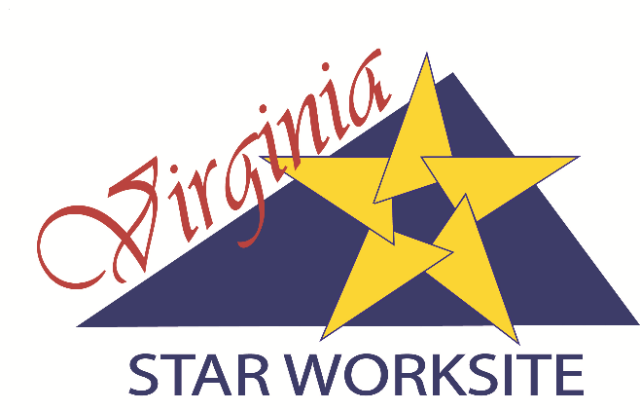
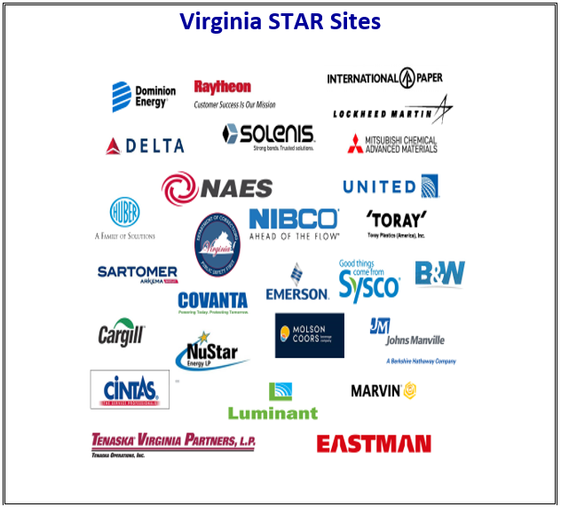
Virginia CHALLENGE
Virginia CHALLENGE is a three stage process that provides employers a step by step process to dramatically improve safety and health management systems to reduce or eliminate injuries, illnesses and fatalities and the substantial costs associated with them. When a company completes Virginia Challenge, it will have an exemplary safety and health management system (SHMS) that will also prepare it to apply for Virginia STAR recognition. https://www.doli.virginia.gov/voluntary-protection-program/challenge/
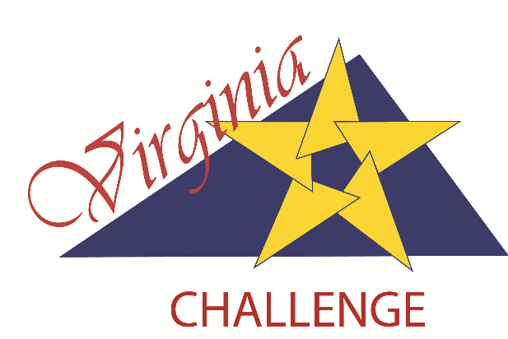
As of May 1, 2022, Virginia CHALLENGE has 20 participants at various stages in the process 3 having completed Stage 3, 5 having completed Stage 2, 11 having completed Stage 1, and 4 in the application process. https://www.doli.virginia.gov/virginia-challenge-program-participants/
Virginia BEST
Virginia BEST (Building Excellence through Safety, Health and Training) is a strategic partnership between the Department and the Associated General Contractors of Virginia (AGCVA) that provides employers a step by step process through three levels of achievement to dramatically improve safety and health management systems in the construction industry to reduce or eliminate injuries, illnesses and fatalities and the substantial costs associated with them.
As of May 1, 2021, Virginia BEST has 2 Level Two Participants and 7 Level One participants.
VADOC CHALLENGE
The Virginia Department of Labor and Industry’s Virginia Occupational Safety and Health (VOSH) program and the Virginia Department of Corrections (VADOC ) have entered into a strategic partnership to create a first in the nation VADOC Challenge program to recognize safety and health excellence at correctional facilities around the Commonwealth. https://www.doli.virginia.gov/voluntary-protection-program/vadoc-challenge/
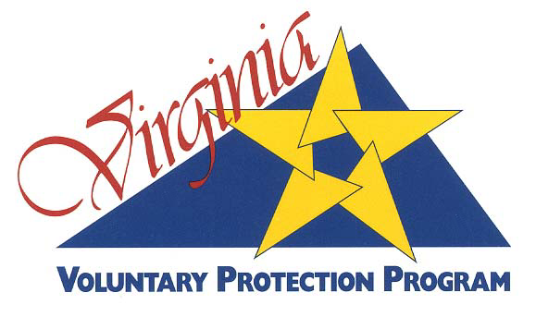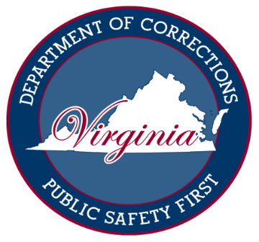

As of May 1, 2021, VADOC CHALLENGE has 8 worksites in the application stage.
Virginia BUILT
Virginia BUILT is a strategic partnership between the Department and the Associated Builders and Contractors – Virginia Chapter (ABC-VA) designed to encourage and recognize ABC-VA members who voluntarily implement highly effective safety and health management systems to benefit construction workers and reduce or eliminate injuries, illnesses and fatalities on construction sites in Virginia. Virginia BUILT’s unique approach to workplace safety and health incorporates a “mentorship” program as a key component. The Mentorship Tier is the introductory tier of participation in the partnership for those employers actively working with the ABC-VA Virginia BUILT Council (VBC) to improve their safety and health management systems to meet VOSH requirements, with the goal of becoming a Tier One participant. Safety and health experts from Tier Two and Tier Three participants serve as the mentors.
https://www.doli.virginia.gov/virginia-built-program/
Another essential component of Virginia BUILT is the incorporation of the ABC STEP program (Safety Training Evaluation Process) as the gateway to participation in Virginia BUILT. Founded in 1989 as a safety benchmarking and improvement tool, STEP has evolved into a world-class safety management system that dramatically improves safety performance among participants regardless of company size or type of work. Participating ABC member firms measure their safety processes and policies on 24 key components resulting in recognition through progressive levels of achievement (Bronze, Silver, Gold, Platinum, and Diamond).
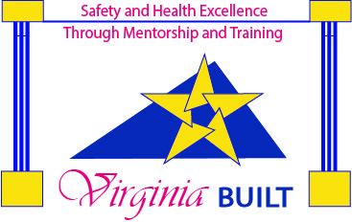
As of May 1, 2021, Virginia BUILT has 1 Tier II participant.
Accomplishments
The VOSH program strives to maintain equally strong enforcement and cooperative program elements; and has accomplished many important achievements that benefit Virginia’s employees and employers:
Virginia’s injury and illness rates are consistently well below the national average in both private and public sector employment.

Total Recordable Cases (TRC) | National | Virginia | Difference
2019 Overall | 2.9 | 2.3 | -20.7%
2019 Private Industry | 2.7 | 2.1 | -22.2%
2019 Construction | 2.5 | 2.3 | -8.0%
2019 Manufacturing | 3.1 | 3.2 | 3.2%
2019 State and Local Government | 3.9 | 3.0 | -23.1%

- A national top eleven ranking in the rate of state occupational safety and health inspections per number of employers.

- Development of public service announcement (PSA) videos in the areas of tree trimming operations, overhead high voltage line safety, trenching safety, the dangers of heat stress and fall protection. https://www.youtube.com/user/DOLIVirginia/videos

- An exemplary and unique Apprenticeship Program for VOSH Compliance Safety and Health Officers (CSHO), Industrial Hygienists and Safety and Health Consultants. The Apprenticeship Program has approval through the U. S. Department of Veteran’s Affairs and the Virginia Department of Veteran’s Services as an authorizing agency for benefits under the Montgomery and Webb GI Bills.

- A statute that recognizes the Virginia Voluntary Protection Program and requires the Virginia Safety and Health Codes Board to enact regulations for the operation of VPP in Virginia, Va. Code §40.1-49.13. Governor Terry McAuliffe proposed the legislation that codified the Virginia Voluntary Protection Program (SB 881 and HB 1768). The legislation passed unanimously. Governor McAuliffe held a bill signing ceremony on June 4, 2015. The Virginia Safety and Health Codes Board is currently developing a regulation to implement the statute. Progress on the regulation as it proceeds through the regulatory promulgation process can be tracked on the Virginia Regulatory Town Hall at: http://townhall.virginia.gov/L/ViewChapter.cfm?chapterid=2897

- An annual safety and health conference which is now entering its 28th successful year of outreach to hundreds of employees, employers, unions, associations and government agencies.

- Senate Bill 607 was passed by the 2016 Virginia General Assembly directing the Virginia Safety and Health Codes Board to adopt regulations for the issuance of proposed penalties to the Commonwealth, its agencies, political subdivisions, or any public body. The law became effective July 1, 2016.

The Virginia Safety and Health Codes Board adopted a proposed regulation on February 16, 2017, amending the VOSH Administrative Regulations Manual (ARM), 16VAC25-60-260. The final regulation was adopted on November 30, 2017. The regulation took effect November 1, 2018, and applies to VOSH inspections opened on or after December 1, 2018. Information on the final regulation is on the Virginia Regulatory Town Hall at: http://townhall.virginia.gov/L/ViewAction.cfm?actionid=4681

- The VOSH program has signed a strategic partnership with the Associated General Contractors of Virginia (AGCVA) to establish a recognition program entitled “Virginia BEST” (Building Excellence in Safety, Health and Training) based on OSHA Challenge concepts. Virginia BEST will work to improve best practices, compliance efforts and accident prevention on construction worksites through recognizing the outstanding efforts of exemplary employers. The program will work with highly successful employers who have demonstrated continual improvement in the arena of occupational safety and health and who are willing to share resources, best practices and advise the construction industry at large. A formal signing ceremony of the strategic partnership occurred on October 13, 2016. More information on Virginia BEST can be found at:
http://www.doli.virginia.gov/vosh_enforcement/BEST_program.html

- The 2017 Virginia General Assembly approved 100% general fund monies to fund the three Consultation and Training and three Voluntary Protection Program staff positions.

- The 2021 Virginia General Assembly approved 100% general fund monies to fund 12 previously unfunded benchmark compliance safety and health officer (CSHO) positions.

Local (Virginia) Emphasis Programs: First Report of Injuries and Illnesses; Fall Hazards; Trenching and Excavation; Scaffolding; Public Sector Workshops; Logging and Sawmill Industries; Reverse Signal Operation of Vehicles, Machinery, Equipment, and Heavy Equipment; Overhead High Voltage Line Safety; Tree Trimming Operations; Asbestos; and Wastewater and Water Treatment Facilities
National Emphasis Programs: Primary Metal Industries; Amputations; Combustible Dust; Crystalline Silica; Process Safety Management Covered Chemical Facilities; Isocyanates; Lead; Facilities That Manufacture Food Flavorings Containing Diacetyl; and Hexavalent Chromium
State and local government employers are not currently subject to penalties. However, the Virginia General Assembly has authorized the Virginia Safety and Health Codes Board to consider adoption of penalties for such entities. It is anticipated that the Board will take up consideration of a proposed regulation in 2016. Va. Code §40.1-2.1, effective July 1, 2016.
https://www.bls.gov/iif/soii-data.htm#summary, National data. https://www.bls.gov/iif/oshstate.htm#VA, Virginia data.
https://aflcio.org/sites/default/files/2021-05/DOTJ2021_Final.pdf, page 174.

